**AIM:**

**SOURCE CODE:**

<!DOCTYPE html>

<html>

<head>

<title>formatting tags</title>

</head>

<body>

<h3>FORMATING TAGS</h3>

<h1>physical tags</h1>

<i>Bapatla Engineering College</i><br>

<b>Bapatla Engineering College</b><br>

<big>Bapatla Engineering College</big><br>

<small>Bapatla Engineering College</small><br>

<u>Bapatla Engineering College</u><br>

bec<sub>Bapatla Engineering College</sub><br>

bec<sub>Bapatla Engineering College</sub>

<H1>logical tags</H1>

<p><abbr title="Bapatla Engineering College">BEC</abbr></p>

<p><dfn title="hypertext mark language">html</dfn></p>

<p><mark>bapatla</mark>engineering college<br>

<p>cse,it,ece,<ins>cs,cs</ins></p>

<P>ece,it,cse<del>,chemical,mech</del>

<p><strong>bapatla engineering college</strong><br>

<p><bdo dir="rtr">HTML</bdo></p>

<p><bdo dir="rtl">HTML</bdo></p>

<p><q>bapatla engineering colege</q><br>

<p>There are two types of errors in java<q>compile time and run time</q></p>

<p>There is an <em>acronym</em> for hypertext markup language</p>

<p><kbd>enter</kbd>key to excute the application</p>

<code>

&lt;!DOCTYPE &gt;

</code>

<p>The <samp> substring()</samp> method returns a new string instance</p>

</body>

</html>

**OUTPUT:**

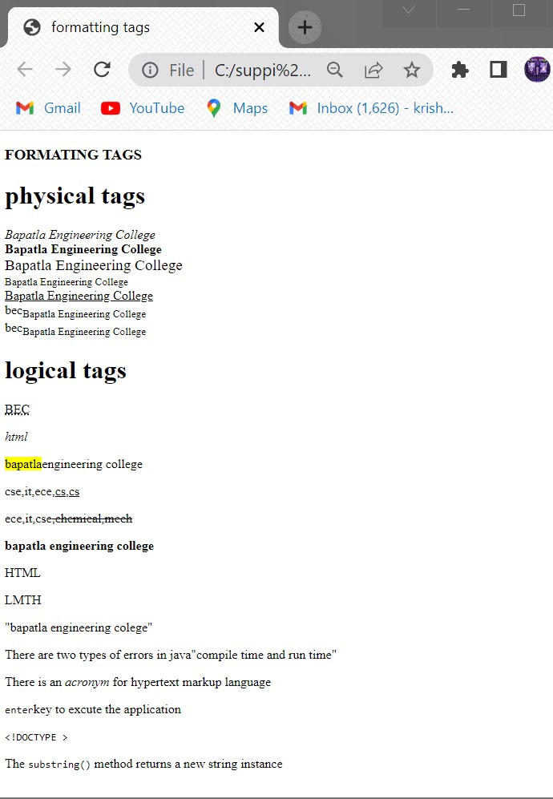

**AIM:**

**SOURCE CODE:**

<!DOCTYPE html>

<html>

<body>

<h2>An unordered HTML List</h2>

<ul>

<li>coffee</li>

<li>tea</li>

<li>milk</li>

</ul>

<h2>An ordered HTML List</h2>

<ol>

<li>coffee</li>

<li>tea</li>

<li>milk</li>

</ol>

<h2> Description list</h2>

<dl>

<dt>Coffee</dt>

<dd>- black hot drink</dd>

<dt>Milk</dt>

<dd>- white cold drink</dd>

</dl>

</body>

</html>

**OUTPUT:**

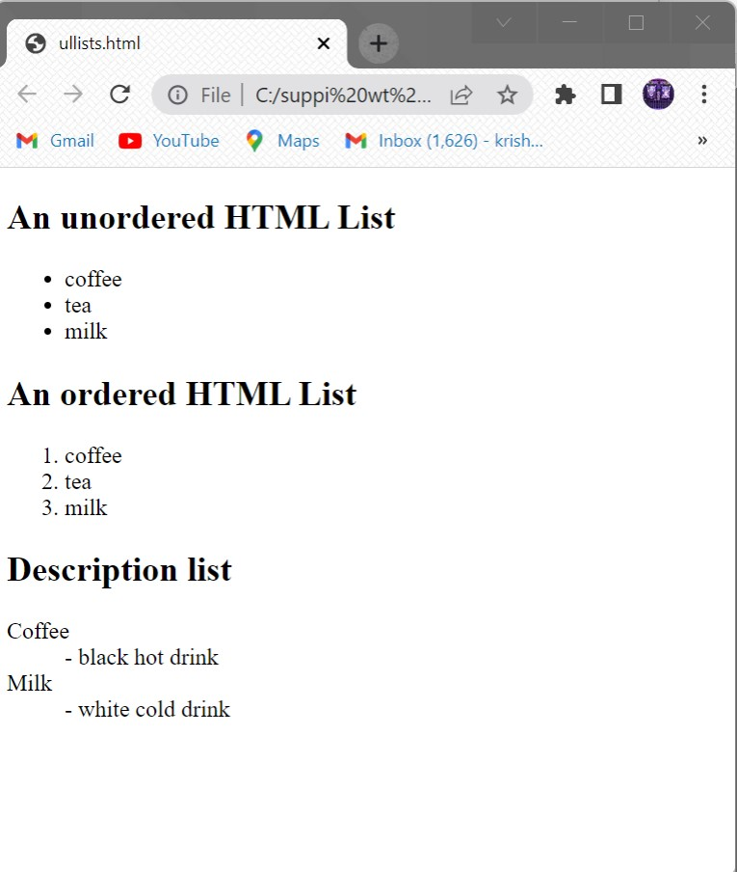

**AIM:**

**SOURCE CODE:**

<!DOCTYPE html>

<html>

<head>

<title>TIME TABLE</title>

</head>

<body>

<div style="width:10%;float:left">

</div>

<h3><center>Bapatla Engineering College::Bapatla</h3>

<h4><center>(Autonoumus)</h4>

<center><h4>Department of Information Technology</h4>

<h4 style="color:red">Class Time Tablefor the <u><mark>A.Y 2021-22,IV

Semester</mark></u></h4>

<hr>

<pre>

<h3>

w.e.f: 28-03-20222 class: II B.Tech,IT Section: A Room No: RPLH-03</h3>

</pre>

<table style="border-collapse:collapse" border="10">

<col style="background-color:orange">

<tr style="background-color:orange">

<th>Time<pre>Day</pre></th>

<th>7:30-<pre>8:20</th>

<th>8:20-<pre>9:10</th>

<th>9:10-<pre>10:00</th>

<th rowspan="8"><pre>B</pre><pre>R</pre><pre>E</pre><pre> A </pre><pre>K <pre> </pre></th>

<th>10:30-<pre>11:20</th>

<th>11:20-<pre>12:10</th>

<th>12:10-<pre>1:00</th>

</tr>

<tr>

<td>Mon</td>

<td>PEHV</td>

<td>Python programming</td>

<td>DBMS</td>

<td>P&S</td>

<td>DAA</td>

<td>WT</td>

<tr>

<td>Tue</th>

<td colspan="3"><pre> <-WT/RDBMS-> </pre></td>

<td>DBMS</td>

<td>Python programming</td>

<td>wt</td>

</tr>

<tr>

<td>Wed</td>

<td>DBMS</td>

<td>P&S</td>

<td>DAA</td>

<td colspan="3"><PRE> <-RDBMS/Python prog lab -></PRE></td>

</tr>

<tr>

<td>Thu</td>

<td>PEHV</td>

<td>Python programming</td>

<td>DBMS</td>

<td>P&S</td>

<td>DAA</td>

<td>WT</td>

</tr>

<tr>

<td>Fri</th>

<td colspan="3"><PRE> <-Python prog lab/Wt lab-></PRE></td>

<td>WT</td>

<td>DAA</td>

<td>DBMS</td>

<tr>

<td>Sat</td>

<td>DBMS</td>

<td>DAA</td>

<td>p&s</td>

<td>PEHV</td>

<td>PEHV</td>

<td style=background-color:green> Mentoring</td>

</tr>

</table>

<pre>

<big><mark>Section Coordinator:Mr.k.Suresh Kumar,Asst.professor</b>

</pre>

<table>

<tr style="background-color:orange">

<td>sub:code</td>

<td>sub name</td>

<td>faculty name</td>

<td>sub code</td>

<td>sub name</td>

<td>faculty name</td>

</tr>

<tr>

<td>20IT401</td>

<td>p&s</td>

<td>Mr.pothuraju</td>

<td>20It461</td>

<td>Mr.sk.Mabhasa</td>

<td>Wtlab</td>

</tr>

<tr>

<td>20IT402</td>

<td>wt</td>

<td>Mr.sk.Mabhasa</td>

<td>20It402</td>

<td>RDBMS</td>

<td>Mr.Ravi kumar</td>

</tr>

<tr>

<td>20IT403</td>

<td>DBMS</td>

<td>Mr.Ravi kumar</td>

<td>20It403</td>

<td>python lab</td>

</tr>

<tr>

<td>20IT404</td>

<td>DAA</td>

<td>Mr.sivaram prasad</td>

<td></td>

<td></td>

<td></td>

</tr>

<tr>

<td>MO12</td>

<td>PEHV</td>

<td>Dr.k.srinivasarao</td>

<td></td>

<td></td>

<td></td>

</tr>

</table

<hr>

<pre>

<h3>

w.e.f: 28-03-20222 class: II B.Tech,IT Section: A Room No: RPLH-03</h3>

</pre>

<table style="border-collapse:collapse" border="10">

<col style="background-color:orange">

<tr style="background-color:orange">

<th>Time <pre>Day</th>

<th>7:30-<pre>8:20</th>

<th>8:20-<pre>9:10</th>

<th>9:10-<pre>10:00</th>

<th rowspan="7"><pre> B</pre><pre> R </pre><pre>E</pre><pre> A

</pre><pre>K </pre></th>

<th>10:30-<pre>11:20</th>

<th>11:20-<pre>12:10</th>

<th>12:10-<pre>1:00</th>

</tr>

<tr>

<td>Mon</th>

<td colspan="3"><-WT/RDBMS-></td>

<td>DBMS</td>

<td>Python programming</td>

<td>wt</td>

</tr>

<tr>

<td>Tues</td>

<td>P&S</td>

<td>Python programming</td>

<td>DAA</td>

<td>PEHV</td>

<td>DBMS</td>

<td>WT</td>

</tr>

<tr>

<td>Wed</td>

<td>PEHV</td>

<td>Python programming</td>

<td>DBMS</td>

<td>P&S</td>

<td>DAA</td>

<td>WT</td>

</tr>

<tr>

<td>Thu</td>

<td>P&S</td>

<td>WT</td>

<td>DAA</td>

<td colspan="3"><PRE> <-RDBMS/Python prog lab -></PRE></td>

</tr>

<tr>

<td>Wed</td>

<td>PEHV</td>

<td>Python programming</td>

<td>DBMS</td>

<td>P&S</td>

<td>DAA</td>

<td>WT</td>

</tr>

<tr>

<td>Sat</td>

<td>DAA</td>

<td>DBMS</td>

<td>p&s</td>

<td>PEHV</td>

<td>WT</td>

<td style=background-color:green> Mentoring</td>

</tr>

</table>

<pre>

<big><mark>Section Coordinator:Mr.k.Suresh

Kumar,Asst.professor</b>

</pre>

<table>

<tr style="background-color:orange">

<td>sub:code</td>

<td>sub name</td>

<td>faculty name</td>

<td>sub code</td>

<td>sub name</td>

<td>faculty name</td>

</tr>

<tr>

<td>20IT401</td>

<td>p&s</td>

<td>Mr.karunakar</td>

<td>20It461</td>

<td>Wtlab</td>

<td>Mr.sk.Mabhasa</td>

</tr>

<tr>

<td>20IT402</td>

<td>wt</td>

<td>Mr.sk.Mabhasa</td>

<td>20It402</td>

<td>RDBMS</td>

<td>Mr.Ravi kumar</td>

</tr>

<tr>

<td>20IT403</td>

<td>DBMS</td>

<td>Mr.Ravi kumar</td>

<td>20It403</td>

<td>python lab</td>

<td>Mr.k.Prasanth</td>

</tr>

<tr>

<td>20IT404</td>

<td>DAA</td>

<td>Mr.Ratna prakash</td>

<td></td>

<td></td>

<td></td>

</tr>

<tr>

<td>MO12</td>

<td>PEHV</td>

<td>Dr.k.srinivasarao</td>

<td></td>

<td></td>

<td></td>

</tr>

</table><pre>

<pre>

<big> HOD PRINCIPAL </big>

</pre>

**OUTPUT:**

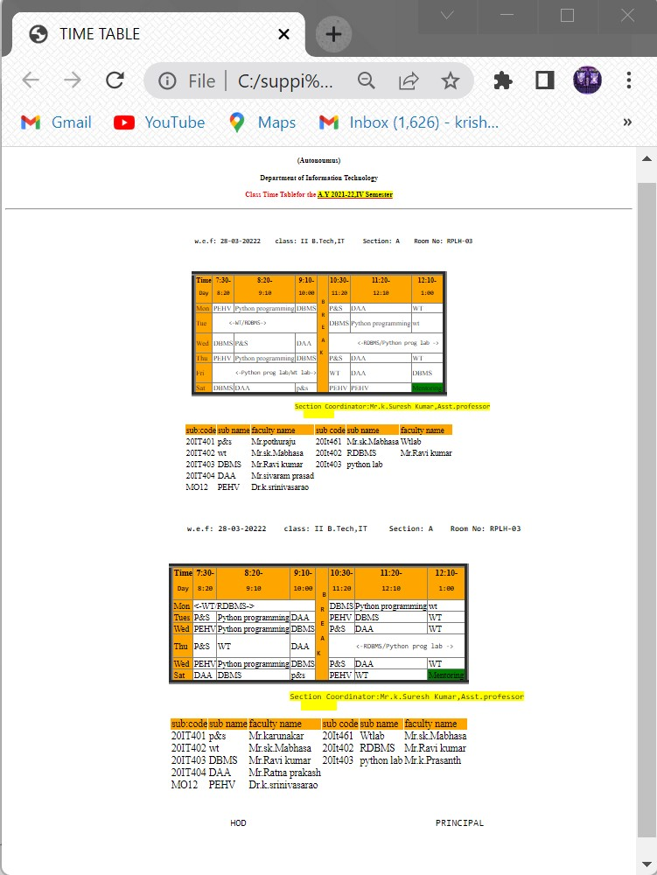

**AIM:**

**SOURCE CODE:**

<!DOCTYPE html>

<html>

<body>

<title> hyper link</title>

<p>click here to open <a href="http://www.geeksforgeek.com" target="_blank">geeks for geek webpage</a></p>

<p> click here to open<a href=studentdetails.html" target="_top">details</a></p>

<p><a href="http://www.becbapatla.ac.in" target="_self"><img src="beclogo.png" height="200" width="200"></a></p>

<a id ="top"></a>

<h1>top of the page</h1>

<a href="#bottom">click to bottom</a><br>

<a href="#middle">click to middle</a>

<p>click here </p>

<p>click here </p>

<p>click here </p>

<p>click here </p>

<p>click here </p>

<p>click here </p>

<p>click here </p>

<p>click here </p>

<p>click here </p>

<p>click here </p>

<p>click here </p>

<a id ="middle"></a>

<h1> middle of page</h1>

<a href="#top">click to top</a><br>

<a href="#bottom">click to bottom</a>

<p>click here </p>

<p>click here </p>

<p>click here </p>

<p>click here </p>

<p>click here </p>

<p>click here </p>

<p>click here </p>

<p>click here </p>

<p>click here </p>

<p>click here </p>

<p>click here </p>

<p>click here </p>

<a id ="bottom"></a>

<h1> bottom of page</h1>

<a href="#top">click to top</a><br>

<a href="#middle">click to middle</a>

</body>

</html>

**OUTPUT:**

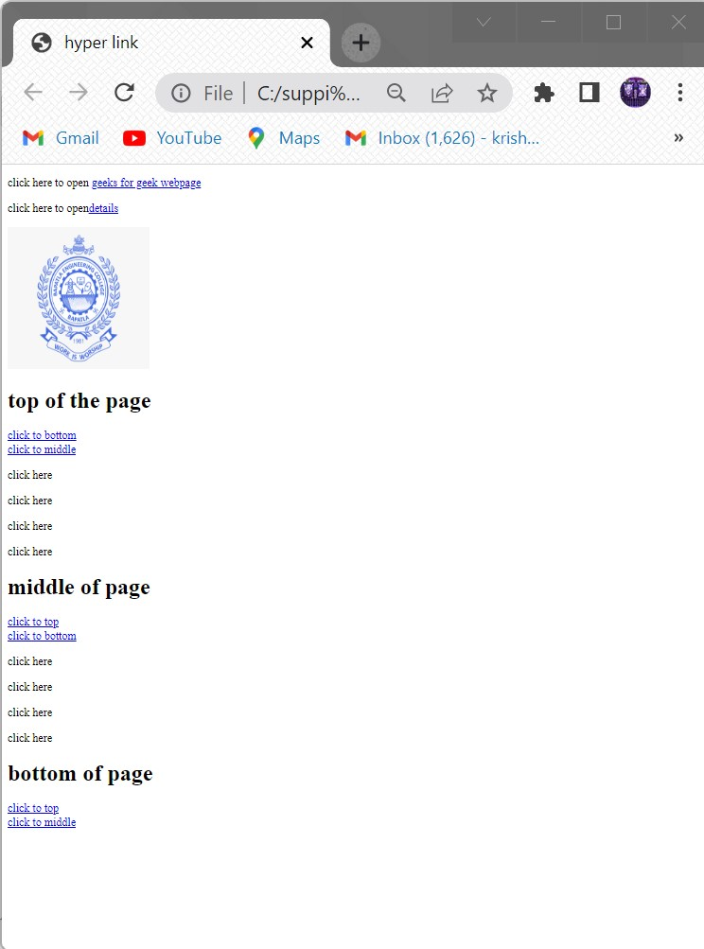

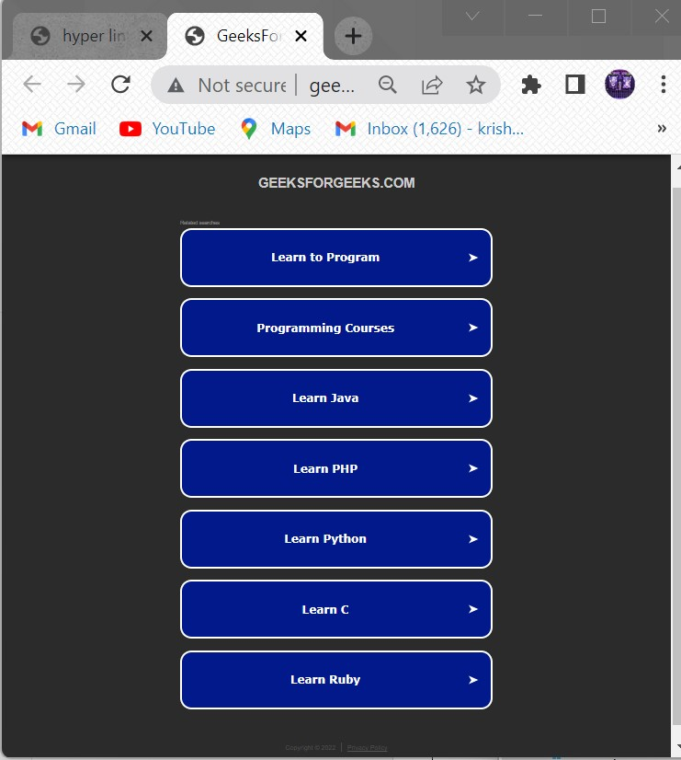

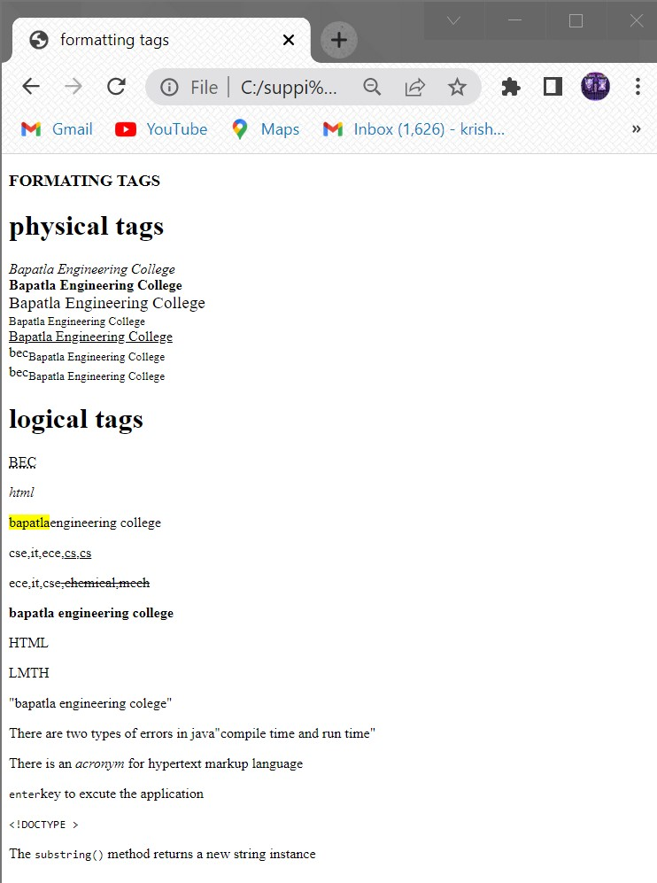

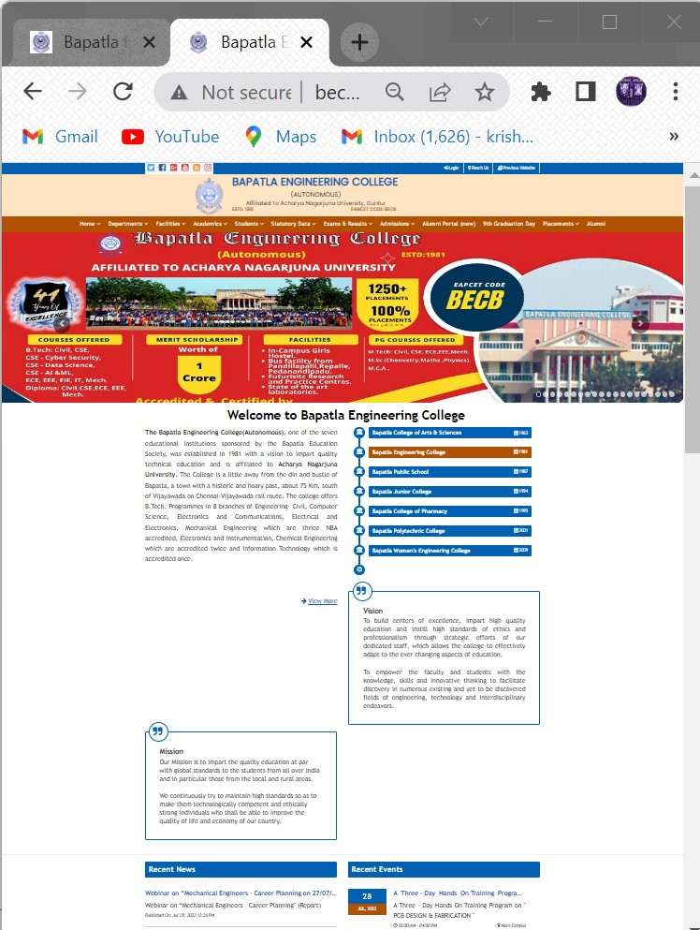

**AIM:**

**SOURCE CODE:**

<!DOCTYPE html>

<html>

<head>

<title>frames</title>

</head>

<frameset rows="20%,20%,40%,20%">

<frame name="header"/>

<frame src="" name="header"/>

<frameset cols="25%,75%">

<frame src="nav.html" name="aside"/>

<frame src="" name="section"/>

</frameset>

<frame src="" name="footer"/>

</frameset>

<html>

**Nav.htmlfile:**

<!DOCTYPE html>

<html>

<head>

<title>frames</title>

</head>

<body>

<center><h1>NAVIGATION</h1>

<nav>

<a id="top"></a>

<a href="#bottom"><img src="down.png" width=150" height="80"></a><br>

Bapatla Engineering College<br>

Bapatla Engineering College<br>

Bapatla Engineering College<br>

Bapatla Engineering College<br>

<a id="bottom"></a>

<a href="#top"><img src="top.jpg" width="80" height="80">bottomimage</a>

</nav>

</BODY>

</HTML>

**OUTPUT:**

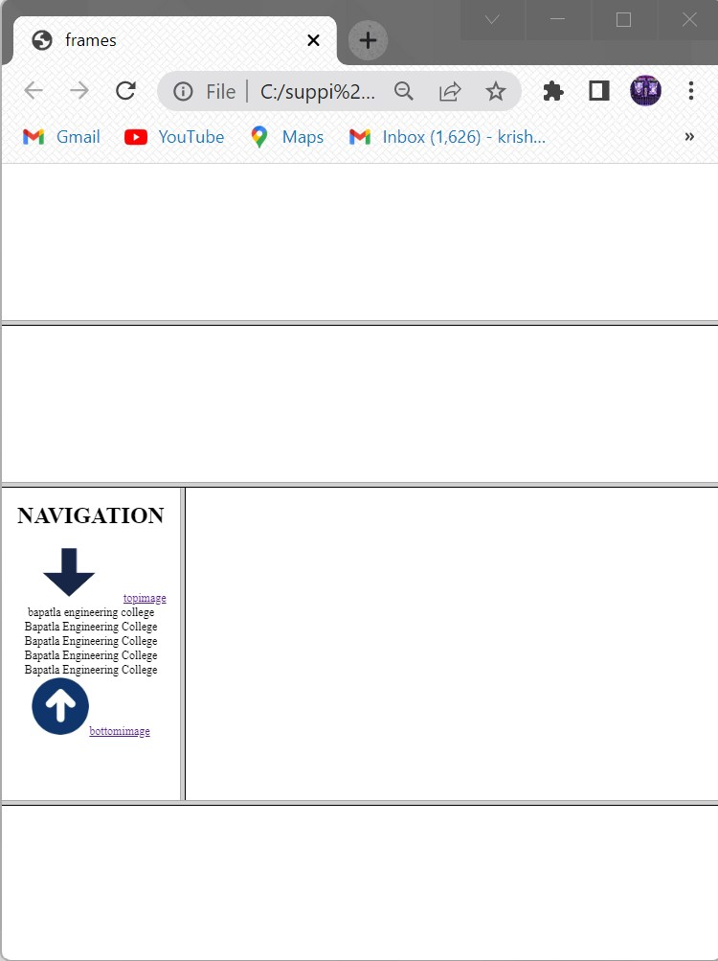

**AIM:**

**SOURCE CODE:**

<!doctype html>

<html>

<head>

<title>image map</title>

</head>

<body>

<h1>working with image map</h1>

<img src="imagemap.jpg" width="500" height="600" alt="india map" usemap="#india">

<map name="india">

<area shape="circle" coords="200,400,50" href="https://psc.ap.gov.in/">

<area shape="rect" coords="150,70,80,150" href="https://registration.telangana.gov.in/">

<area shape="crcle" coords="300,200,150" href="https://jammu.nic.in/">

<area shape="rect" coords="150,70,80,150" href="https://registration.meghalaya.gov.in/">

<area shape="crcle" coords="300,200,150" href="https://gujarat.nic.in/">

<area shape="rect" coords="150,70,80,150" href="https://registration.maharashtra.gov.in/">

<area shape="rect" coords="150,70,80,150" href="https://registration.bihar.gov.in/">

<area shape="crcle" coords="300,200,150" href="https://rajasthan.nic.in/">

<area shape="crcle" coords="300,200,150" href="https://kerala.nic.in/">

</body>

</html>

**OUTPUT:**

**AIM:**

**SOURCE CODE:**

<!DOCTYPE HTML>

<html>

<head>

<title>forms application</title>

</head>

<body style="background-color:cyan">

<form>

<center><table border="1px"width="1000" style="text-align:center">

<tr>

<td><h1>Student Registration Form</h1>

</td>

</tr>

</table></center><br><br>

<label>Name :</label>

<input type="text" placeholder="Enter ful name" size="70"><br/><br/>

<label>Father's Name :</label>

<input type="text" size="70"><br/><br>

<label>Mother's Name :</label>

<input type="text" size="70"><br/><br>

<label>Phone Number :</label>

<input type="number" placeholder="017*******" size="70"><br/><br>

<label>Email :</label>

<input type="email" placeholder="sample@example.com" size="70"><br/><br>

<label>Gender : :</label>

<input type="radio" value="Male"name="gender">Male

<input type="radio" value="Female"name="gender">Female

<input type="radio" value="Other"name="gender">Other<br/><br>

<label>Date of birth</label>

<input type="text"size="10">-

<input type="text"size="10">-

<input type="text"size="10">(dd-mm-yy)<br><br

<label>Address :</label>

<textarea rows="1"cols="100">

Street- House-Road

</textarea><br><br>

<label>Blood Group: :</label>

<select >

<option>select</option>

<option>A</option>

<option>A+</option>

<option>B</option>

<option>B+</option>

<option>AB+</option>

<option>AB-</option>

<option>O-</option>

<option>O+</option>

</select><br/><br>

<label>Department :</label>

<label> :</label>

<input type="radio" value="CSE"name="department">CSE

<input type="radio" value="EEE"name="department">EEE

<input type="radio" value="BBA"name="department">BBA<br/><br>

<label>Course</label>

<input type="checkbox"value="c">c

<input type="checkbox"value="c++">c++

<input type="checkbox"value="java">java

<input type="checkbox"value="AI">AI

<input type="checkbox"value="Machine learning">Machine learning

<input type="checkbox"value="Robotics">Robotics<br><br>

<label>Photo :</label>

<input type="file"><br><br><br><br>

<a href="p1.html">Submit</a>

</body>

</html>

**OUTPUT:**

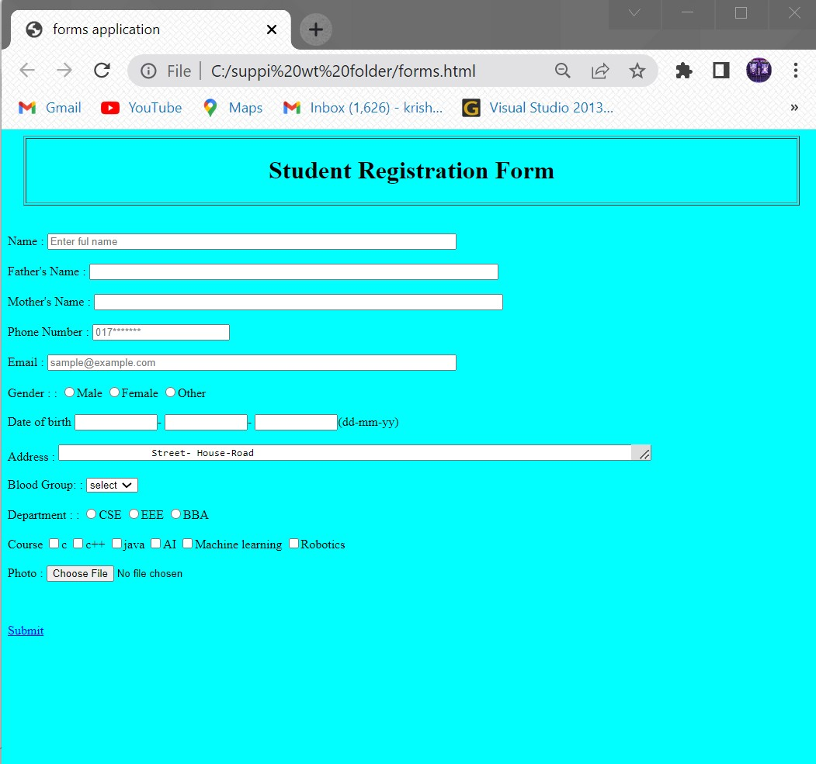

**AIM:**

**SOURCECODE:**

<!DOCTYPE html>

<html>

<head>

<title>FORM</title>

</head>

<body>

<form action="https://www.w3schools.com/tags/tag_legend.ASP">

<fieldset style="background:yellow;border-color:red">

<legend style="background:blue;color:white">Details</legend>

<label>NAME:</label>&nbsp&nbsp&nbsp&nbsp

<input type="text" name="NAME:"><br><br><br>

<label>Father Name:</label>

<input type="text" name="Father Name:"><br><br><br>

<label>Address:</label>

<textarea name="Address:"></textarea><br><br><br>

<label>BloodGroup:</label>

<select>

<option>select</option>

<option>A+</option>

<option>B+</option>

<option>AB+</option>

<option>A-</option>

<option>B-</option>

<option>AB-</option>

</select><br>

<label> Colleges:</label>

<select>

<optgroup label="Engineering colleges">

<option>BEC</option>

<option>GEC</option>

<option>LBRCE</option>

</optgroup>

<optgroup label="Inter colleges">

<option>Inter colleges</option>

<option>Chaithanya college</option>

<option>Narayana college</option>

</optgroup>

</select><br><br>

<input type="submit" >

</fieldset>

</form>

</body>

</html>

**OUTPUT:**

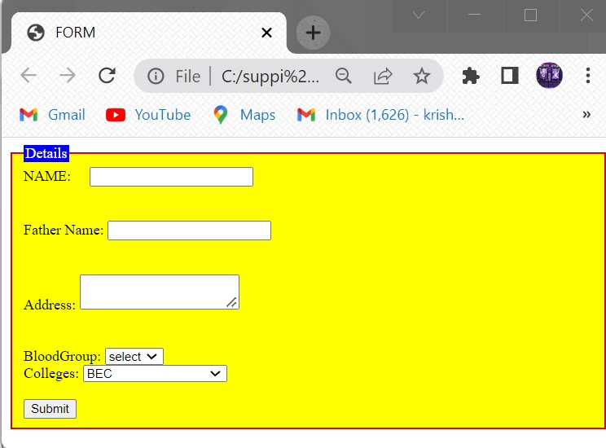

**AIM:**

**SOURCECODE:**

<!doctype html>

<html>

<head>

<title>inline</title>

<body style="color:red; background-color:pink; font-family:sans-serif">

<h1 style="font-size:18pt">The fontsize of this heading is 18pt</h1>

<p style="font-size:12pt">The fontsize of this paragraph is 12pt</p>

<h1 style=" color:red; background-color:yellow font-size:18pt">The fontsize of this heading is 18pt</h1>

<p style="color:#ffff00; font-size:12pt">The fontsize of this paragraph is 18pt</p>

</body>

</html>

**OUTPUT:**

**AIM:**

**SOURCECODE:’**

<!DOCTYPE HTML>

<HEAD>

<TITLE>CSS Example </TITLE>

<STYLE>

*{margin: 0;}

body {

color:red;

background-color:lightgrey;

font-family: sans-serif;}

h1{font-size:18pt}

p{font-size:12pt}

</STYLE>

</HEAD>

<BODY>

<H1>The font size of this heading is 18pt</H1>

<P>The font size of this paragraph is 12pt</P><BR/><BR/>

<H1 style="color:#ff0000;background-color:#ffff00;font-family: Ariel;">

The font size of this heading is 18pt </H1>

<P style="color:yellow; font-size:10pt">The font size of this paragraph is 12pt</P>

</BODY>

</HTML>

**OUTPUT:**

**AIM:**

**SOURCECODE:**

<!DOCTYPE HTML>

<HEAD>

<TITLE>CSS Example </TITLE>

<LINK rel="stylesheet" type="text/css" href="example.css"/>

</HEAD>

<BODY>

<H1>The font size of this heading is 18pt</H1>

<P>The font size of this paragraph is 12pt</P>

<TABLE>

<TR>

<TH>living being</TH>

<TH>shelter</TH>

</TR>

<TR>

<TD class="code">Lion</TD>

<TD>Lion lives in the den</TD>

</TR>

<TR>

<TD class="code">Man</td>

<TD>Man lives in house</TD>

</TR>

<TR>

<TD class="code">Fish</TD>

<TD>Fish lives in water</TD>

</TR>

<TR>

<TD class="code">Bird</TD>

<TD>Bird lives in nest</TD>

</TR>

</TABLE>

</BODY>

</HTML>

**Example.css:**

*{margin: 0;}

body

{

color:#000000;

background-color:#00ff00;

font-family: sans-serif;

}

h1{font-size:18pt}

p{font-size:12pt}

table

{

background-color:#efefef;

border-style:solid;

border-width:2px;

border-color:#999900;

}

th

{

background-color:#cccc00;

font-weight:bold;

padding:3px;

}

td{padding:3px}

td.code

{

font-family: serif;

font-weight:bold

}

**OUTPUT:**

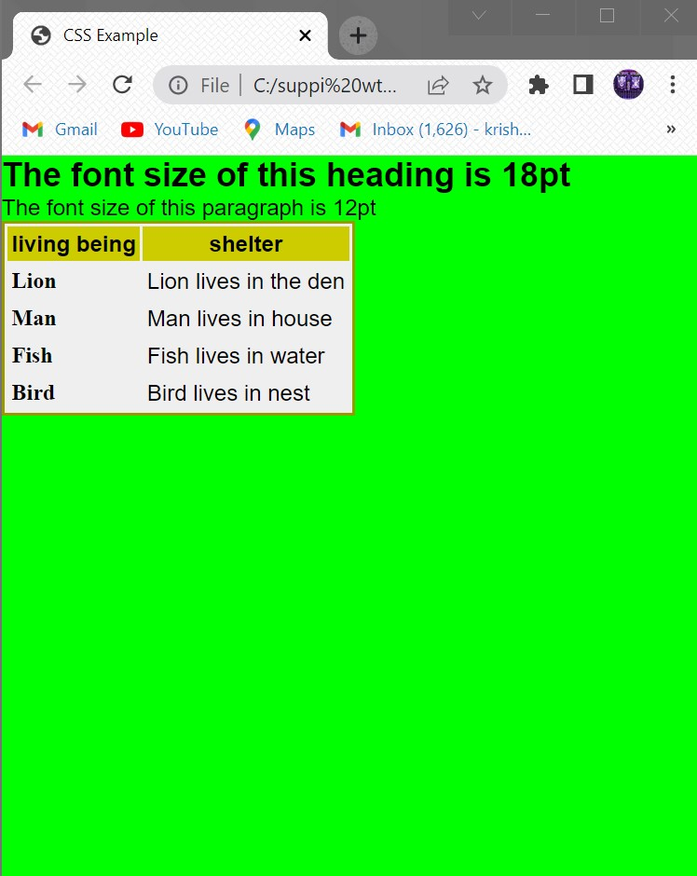

**AIM:**

**SOURCECODE:**

<!DOCTYPE HTML>

<HEAD>

<TITLE>CSS Example </TITLE>

<STYLE TYPE="text/css">

@import url("example.css");

P {color:blue}

</STYLE>

</HEAD>

<BODY>

<H1>The font size of this heading is 18pt</H1>

<P>The font size of this paragraph is 12pt</P>

<TABLE>

<TR>

<TH>living being</TH>

<TH>shelter</TH>

</TR>

<TR>

<TD class="code">Lion</TD>

<TD>Lion lives in the den</TD>

</TR>

<TR>

<TD class="code">Man</TD>

<TD>Man lives in house</TD>

</TR>

<TR>

<TD class="code">Fish</TD>

<TD>Fish lives in water</TD>

</TR>

<TR>

<TD class="code">Bird</TD>

<TD>Bird lives in nest</TD>

</TR>

</TABLE>

</BODY>

</HTML>

**Example.css:**

*{margin: 0;}

body

{

color:#000000;

background-color:#00ff00;

font-family: sans-serif;

}

h1{font-size:18pt}

p{font-size:12pt}

table

{

background-color:#efefef;

border-style:solid;

border-width:2px;

border-color:#999900;

}

th

{

background-color:#cccc00;

font-weight:bold;

padding:3px;

}

td{padding:3px}

td.code

{

font-family: serif;

font-weight:bold;

}

**OUTPUT:**

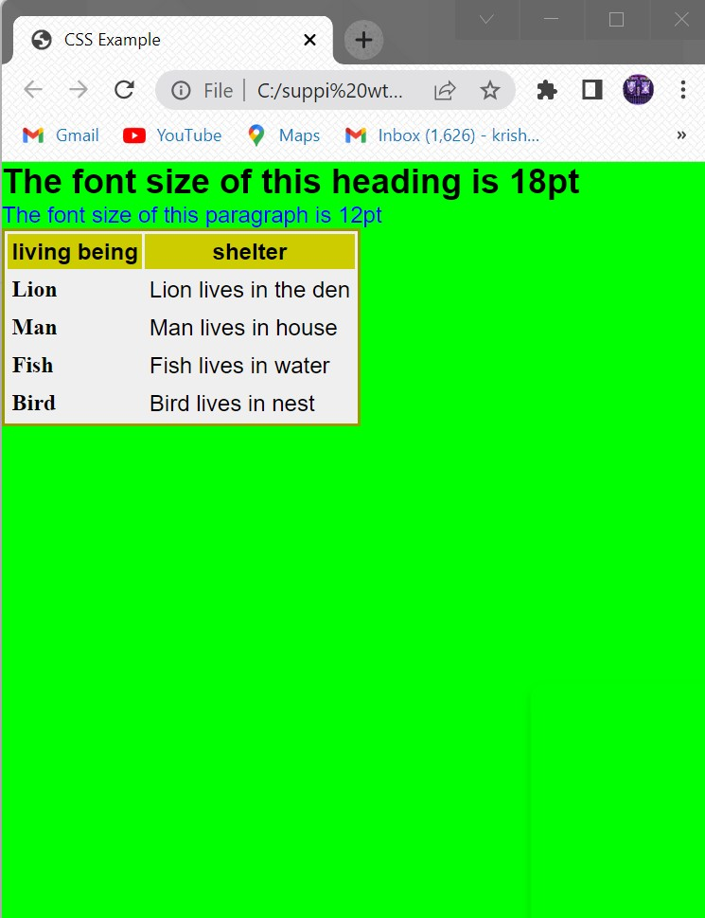

**AIM:**

**SOURCECODE:**

<!DOCTYPE html>

<html>

<head>

<title>query selector</title>

<script type"text/javascript">

function queryselector(){

p=document.querySelector("#p2");

p.style.background="green";

}

function queryselectorall(){

p=document.querySelectorAll("p");

for(var i=0;i<p.length;i++){

p[i].style.color="pink";

}

}

</script>

</head>

<body>

<p>myparagraph</p>

<p id="p2">my paragraph 2</p>

<p>myparagraph 3</p>

<p>myparagraph 4</p>

<button onclick="queryselector()">Query selector</button>

<button onclick="queryselectorall()">Query selector All</button>

</body>

</html>

**OUTPUT:**

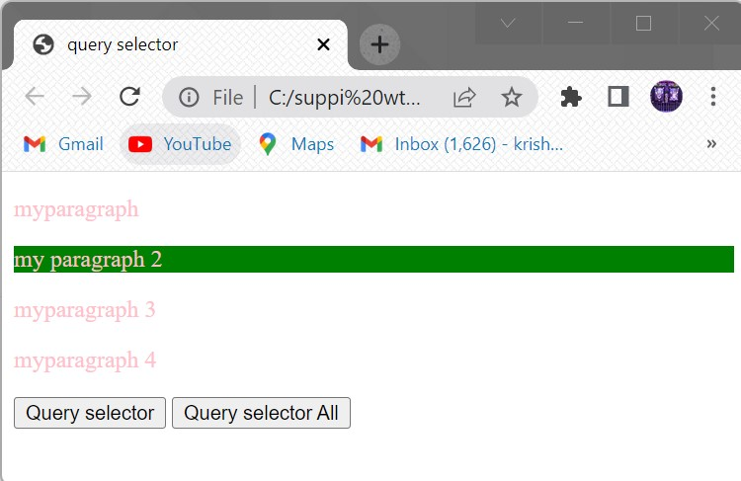

**AIM:**

**SOURCECODE:**

**Mouseevents:**

<!DOCTYPE html>

<html>

<head>

<title>mouse events</title>

<style>

#f1{

border:1px solid black;

width:200px;

height:100px;

overflow:scroll;

}

</style>

<script type="text/javascript">

function mouseclick(){

document.getElementById("btn1").style.background="pink";

}

function mousedbclick(){

document.getElementById("btn2").style.color="green";

}

function mousedown(){

document.getElementById("p1").style.color="yellow";

}

function mouseup(){

document.getElementById("p1").style.color="orange";

}

function mousemov(e){

var x=e.clientX;

var y=e.clientY;

document.getElementById("msg").innerHTML="coord are :"+x+""+y;

}

function mouseou(){

document.getElementById("msg").innerHTML="";

}

function mouseove(i){

i.style.width="500px";

i.style.height="500px";

}

function mouseout(i){

i.style.width="100px";

i.style.height="100px";

}

function mousewheel(){

document.getElementById("p2").style.fontSize="35px";

}

</script>

</head>

<body>

<h1><center>Mouse Events</center></h1>

<button id="btn1" onclick="mouseclick()">click here</button><br><br>

<button id="btn2" ondblclick="mousedbclick()">double click here</button><br>

<p id="p1"onmousedown="mousedown()" onmouseup="mouseup()">bapatla

engineering clg</p>

<img src="img1.png"width="200"height="200" onmousemove="mousemov(event)"

onmouseout="mouseou()">

<p id="msg"></p>

<img src="img1.png"width="200"height="200" onmouseover="mouseove(this)"

onmouseout="mouseout(this)">

<p id="p2" onmousewheel="mousewheel()">bapatla engineering clg</p>

</body>

</html>

**OUTPUT:**

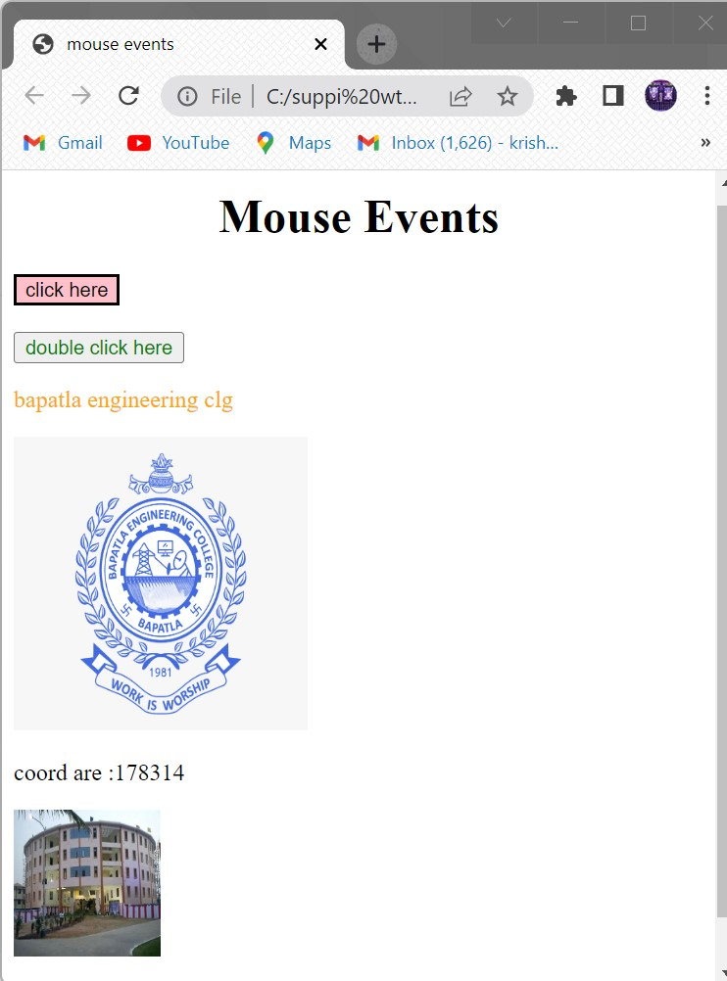

**FORMEVENTS:**

<!DOCTYPE html>

<html>

<head>

<title>form events</title>

<script type="text/javascript">

function blur1(){

var x=document.getElementById("f1");

x.value=x.value.toUpperCase();

}

function change1(x){

x.style.color="red";

}

function focus2(y){

y.style.background="yellow";

}

function input1(){

var x=document.getElementById("f3").value;

document.getElementById("demo").innerHTML="you wrote: "+x;

}

function reset1(){

alert("the form was reset");

}

function search1(){

var x=document.getElementById("f4");

document.getElementById("demo1").innerHTML="you searching for: "+x.value;

}

function select1(){

alert("you select some text");

}

function submit1(){

alert("the form was submitted");

}

</script>

</head>

<body>

ENTER NAME:<input type="text" onblur="blur1()"id="f1"><br><br>

ENTER NAME:<input type="text" onchange="change1(this)" id="f2"><br><br>

ENTER NAME:<input type="text" onfocus="focus2(this)"><br><br>

ENTER NAME:<input type="text" oninput="input1()"id="f3"><br>

<p id="demo"></p>

<form>

NAME:<input type="text" oninvalid="alert('you must fill out the form!');" name="fname" required>

<input type="submit" vaue="submit">

</form>

<form onreset="reset1()">

ENTER NAME:<input type="text">

<input type="reset" value="reset">

</form>

<input type="search" id="f4"onsearch="search1()">

<p id="demo1"></p>

<input type="text" value="hello world!" onselect="select1()">

<form id="f5">

NAME:<input type="text" name="fname" onsubmit="submit1()">

<input type="submit" value="submit">

</form>

</body>

</html>

**OUTPUT:**

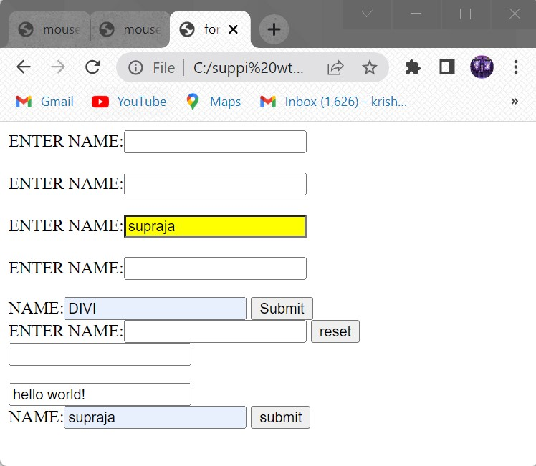

**POPUP BOXES:**

<!DOCTYPE HTML>

<html>

<head>

<title>popup</title>

<script type="text/javascript">

var i;

function alertmsg(){

alert("this is alert meassge");

}

function confirmmsg(){

i=confirm("click yes or no");

document.write(i);

}

function promptmsg(){

i=prompt("enter the value");

document.write(i);

}

</script>

</head>

<body>

<h1>demonstrate the pop up meassages</h1>

<button onclick="alertmsg()">alertbox</button>

<button onclick="confirmmsg()">confirmbox</button>

<button onclick="promptmsg()">promptbox</button>

</body>

</html>

**OUTPUT:**

**Popup boxes:**

**Confirm box:**

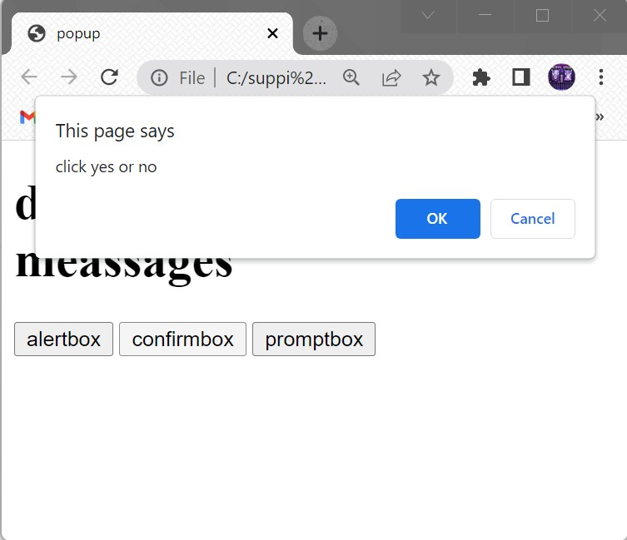

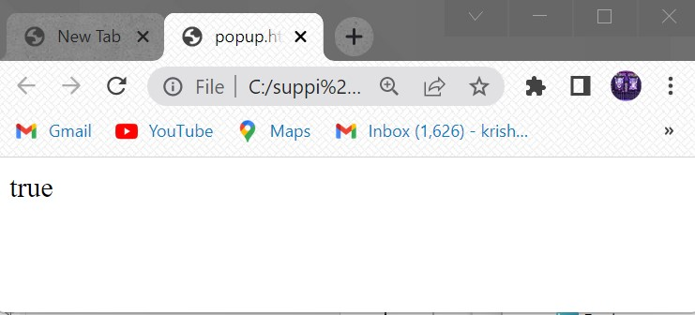

**Prompt:**

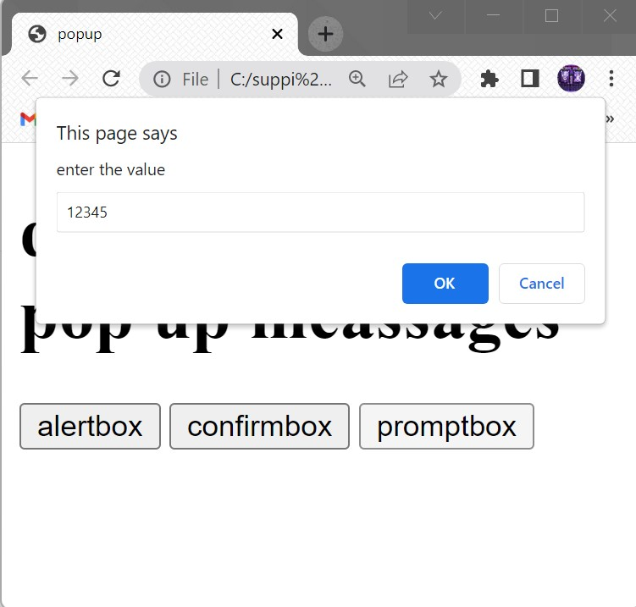

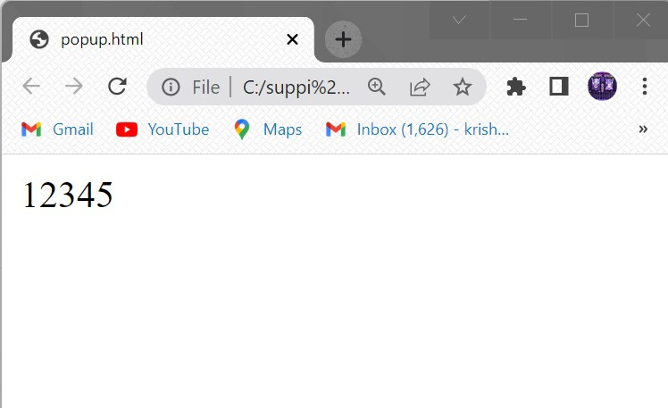

**AIM:**

**SOURCECODE:**

<!DOCTYPE html>

<html>

<head>

<title> String Object</title>

</head>

<body >

<script type="text/javascript">

document. write("<h2> methods in String Objects </h2>");

var str= "welcome to html5";

var str1= "welcome to JS";

document.write("Length of str:"+str.length);

document.write("<br>Character at 5 position:"+str.charAt(5));

document.write("<br>Concat str & str1:"+str.concat(str1));

document.write("<br>Index of 'm' in str:"+str.indexOf('m'));

document.write("<br> last Index of 'm' in str:"+str.lastIndexOf('m'));

document.write("<br>Replace html5 to css3 in str:"+str.replace("html5","css3"));

document.write("<br>slice the test from 0-7 in str:"+str.slice(0,7));

document.write("<br>split the str based on space:"+str.split(" "));

document.write("<br>Upper case of str text:"+str.toUpperCase());

document.write("<br>lower case of str text:"+str.toLowerCase());

document.write("<h2> Wrapper methods in String Objects </h2>");

document.write("small text:"+str.small());

document.write("<br>Big text:"+str.big());

document.write("<br>Bold text:"+str.bold());

document.write("<br>Font color:"+str.fontcolor("pink"));

document.write("<br>Font size:"+str.fontsize("10px"));

document.write("<br>Italic text:"+str.italics());

document.write("<br>Link:"+str.link());

document.write("<br>strike-out text:"+str.strike());

document.write("<br>subscript:"+str.sub());

document.write("<br>supscript:"+str.sup());

document.write("<br>Text Blink:"+str.blink());

</script>

</body>

</html

**OUTPUT:**

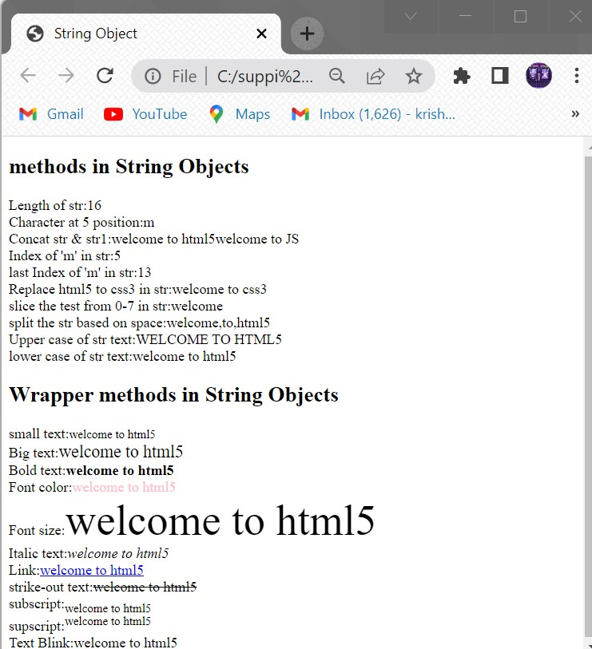

**AIM:**

**SOURCECODE:**

<!DOCTYPE html>

<html>

<head>

<title> Math Object</title>

</head>

<body >

<script type="text/javascript">

document.write("<h2>Math object properties</h2>");

document.write("Euler's number E:"+Math.E);

document.write("<br>natural logarithmic of 2:"+Math.LN2);

document.write("<br>natural logarithmic of 10:"+Math.LN10);

document.write("<br>base-2 logarithmic of E:"+Math.LOG2E);

document.write("<br> base-10 logarithmic of E:"+Math.LOG10E);

document.write("<br>Number value of PI:"+Math.PI);

document.write("<br>Square root of 1/2:"+Math.SQRT1_2);

document.write("<br> Square root of 2:"+Math.SQRT2);

document.write("<h2>Math object methods</h2>");

document.write("absolute value of pi:"+Math.abs(Math.PI));

document.write("<br>natural logarithm of 20:"+Math.log(20));

document.write("<br>max value among (5,6,7,8,9):"+Math.max(5,6,7,8,9));

document.write("<br>min value among (5,6,7,8,9):"+Math.min(5,6,7,8,9));

document.write("<br>the value of S to the power of 2:"+Math.pow (5,2));

document.write("<br>random number between 0 and 1:"+Math.random());

document.write("<br>square root of 16:"+Math.sqrt(16));

</script>

</body>

**OUTPUT:**

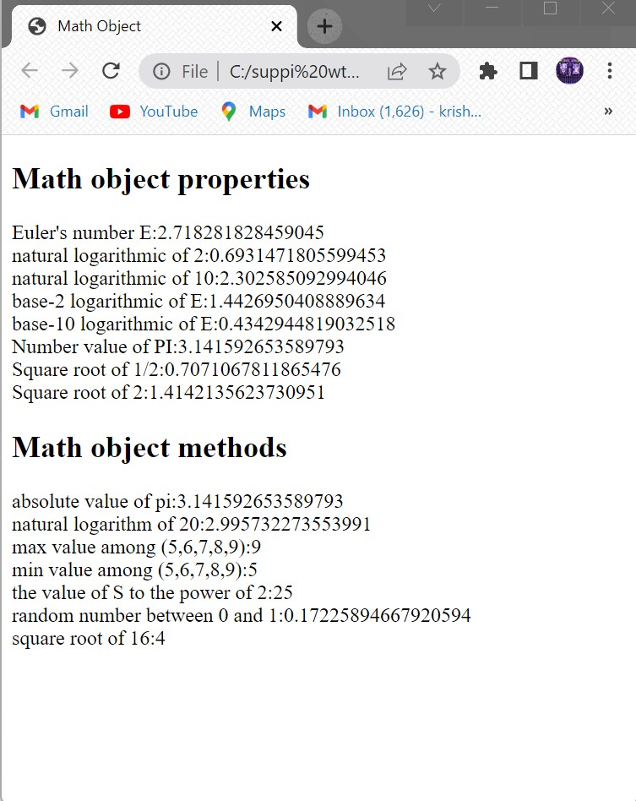

**AIM:**

**SOURCECODE:**

<!DOCTYPE htm|>

<html>

<head>

<title> Date objects</title>

</head>

<body>

<script type="text/javascript">

var d1= new Date();

var d2=new Date(2000000);

var d3=new Date("july 08,2022");

var d4=new Date(2022,00,01);

var d5=new Date(2022,00,01,10,45,30);

document.write("<h2>Date object creation</h2>");

document.write("Empty Date object creation:"+d1);

document.write("<br>Date object with milliseconds:"+d2);

document.write("<br>Date object with string:"+d3);

document.write("<br>Date object with specified date:"+d4);

document.write(" <br> Date object with specified date & time:"+d5);

document.write("<h2>Date object methods</h2>");

document.write("Current Date:"+Date(d1.valueOf()));

document.write("<br>Day:"+d1.getDay());

document.write("<br>Date:"+d1.getDate());

document.write("<br>Month."+d1.getMonth());

document.write("<br>Year:"+d1.getFullYear());

document.write("<br>Hourse:"+d1.getHours());

document.write("<br>Minutes:"+d1.getMinutes());

document.write("<br>Seconds:"+d1.getSeconds());

document.write("<br>Milliseconds:"+d1.getMilliseconds());

document.write("<br>Time:"+Date(d1.getTime()));

document.write("<br>difference between UTC time and local time, in minutes:"+d1.getTimezoneOffset());

document.write("<br>Setting the Date:"+d1.setDate(10));

document.write("<br>getting the Date:"+d1.getDate());

</script>

</body>

</html>

**OUTPUT:**

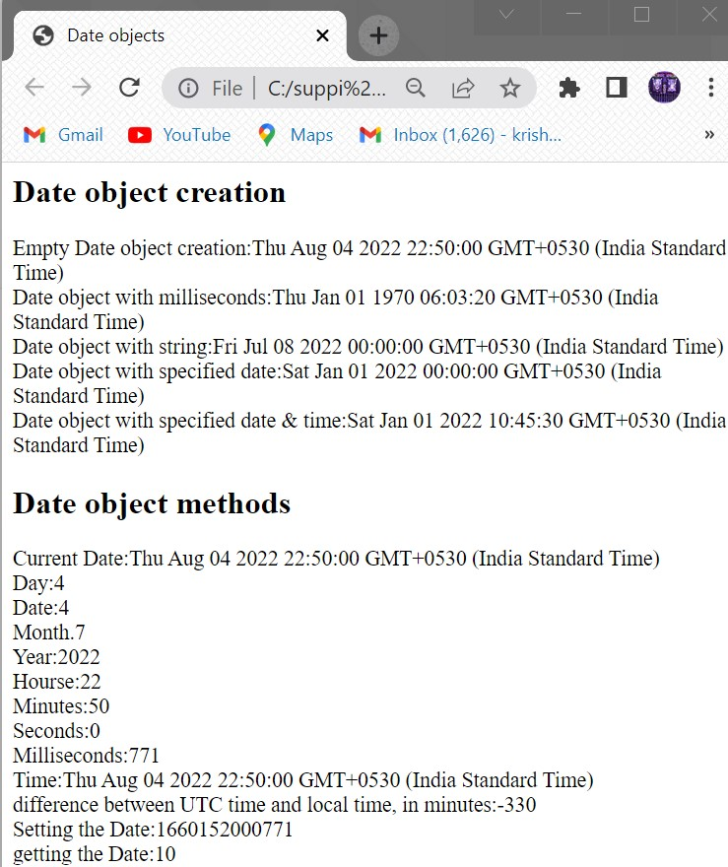

**AIM:**

**SOURCECODE:**

<!DOCTYPE html>

<html>

<head>

<title>Window object</title>

</head>

<body>

<! <h2>Frames</h2>

<iframe src="popups.html" width="200" height="200"></iframe>

<iframe src="App.html" width="200" height="200"></iframe>

<iframe src="" width="200" height="200"></iframe>

<h2>window object methods</h2>

<button id="but1" onclick="win=window.open()">Open Window</button>

<button id="but1" onclick="win.close()">close Window</button>

<button id="but1" onclick="window.alert('Alert Message')">Alert</button>

<button id="but1" onclick="window.prompt('prompt Message)">Prompt</button>

<button id="but1" onclick="window.confirm('confirm message')">confirm</button>

<button id="but1" onclick="win.moveBy(100,100)">Move by Window 100,100 pixel</button>

<h2>window object properties</h2>

<script type="text/javascript">

document.write("Number of Frames:"+window.length);

window.frames[2].location="harika.html";

document.write("<br>height of the windows content area(viewport)including scrollbars:"+window.innerHeight);

document.write("<br>width of the windows content area(viewport)including scrollbars:"+window.innerWidth);

document.write("<br>height of the browser window,including toolbars/scrollbars:"+window.outerHeight);

document.write("<br>width of the browser window,including toolbars/scrollbars:"+window.outerWidtht);

</script>

</body>

</html>

**OUTPUT:**

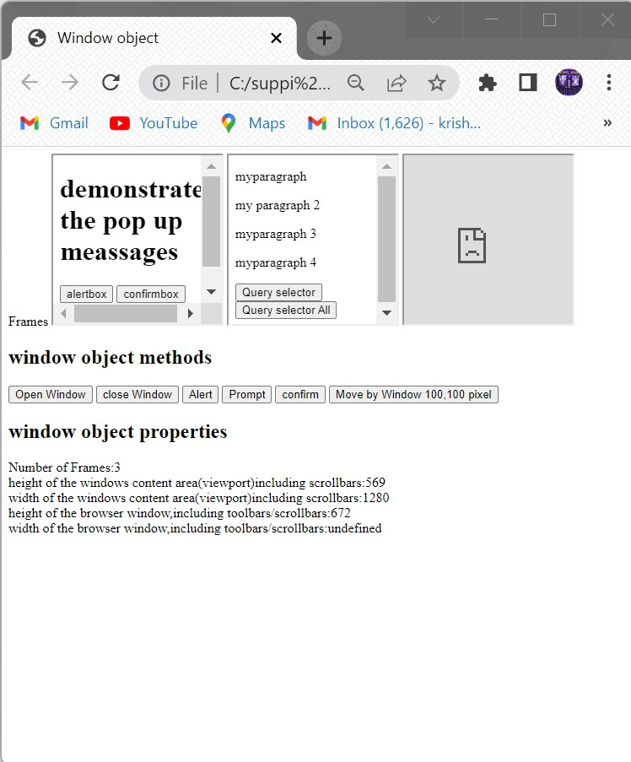

**AIM:**

**SOURCECODE:**

<!DOCTYPE HTML>

<html>

<head>

<title>Document Object</title>

</head>

<body>

<h2>Images</h2>

Iamge 1:<img id ="imgl" src="beclogo.png" width="100" height="100">

Iamge 2:<img id ="img2" src="rp.jpg" width="100" height="100">

<h2>Links</h2>

<a id="link1" href="popup.html">Pagel</a>

<a id ="link2" href="query.html">Page2</a>

<h2>Docuemnt object methods</h2>

<button onclick="open_doc()">Open Docuemnt</button>

<script type="text/javascript">

document.write("<h2>Document object collection</h2>");

document.write("Number of images:"+document.images.length);

document.write("<br>Number of links:"+document.links.length);

document.write("<h2>Document object properties</h2>");

document.write("Title of docuemnt:"+document.title);

document.write("<br>URL of docuemnt:"+document.URL);

document.write("<br> state of docuemnt:"+document.readyState);

document.write("<br>lastmodified of docuemnt:"+document.lastModified);

function open_doc(){

var mywindow = window.open();

mywindow.document.open();

mywindow.document.write("<h1>Welcome to document</h1>");

mywindow.document.close();

}

</script>

</body>

</html>

**OUTPUT:**

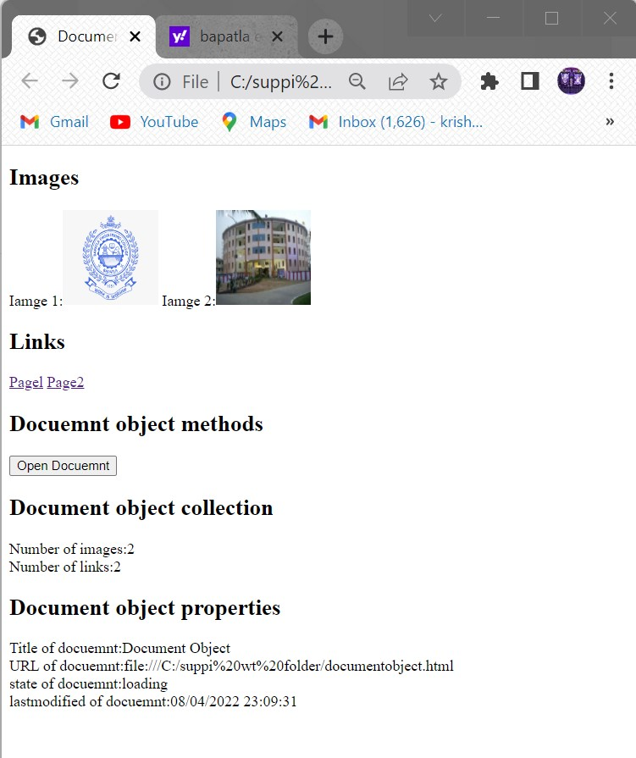

**AIM:write a**

**SOURCECODE:**

<!Doctype html>

<html>

<head>

<title>Node Interface</title>

<script type="text/javascript">

function create_node()

{

var link=document.createElement("a");

link.setAttribute("id","l1");

link.setAttribute("href","Z://WT LAB/popup.html");

link.setAttribute("width","100");

link.setAttribute("height","100");

text=document.createTextNode("My link");

link.appendChild(text)

document.body.appendChild(link);

}

function delete_node()

{

child=document.getElementById("l1");

document.body.removeChild(child);

}

function clone_node()

{

link=document.getElementById("l1");

c=link.cloneNode(true);

document.body.appendChild(c);

}

function insert_node()

{

link=document.getElementById("l1");

para=document.createElement("p");

para.setAttribute("id","p1");

text=document.createTextNode("My Paragraph before link");

para.appendChild(text);

document.body.insertBefore(para,link)

}

</script>

</head>

<body>

<div id="id">

<h2>Node Interface Methods</h2>

<button onclick="create_node()">Create Link</button>

<button onclick="delete_node()">Remove Link</button>

<button onclick="clone_node()">Clone Link</button>

<button onclick="insert_node()">Insert paragraph before Link</button>

</div>

</body>

</html>

**OUTPUT:**

**createlink:**

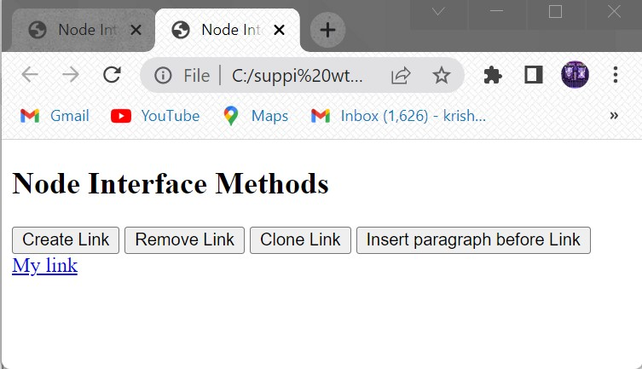

**Clonelink:**

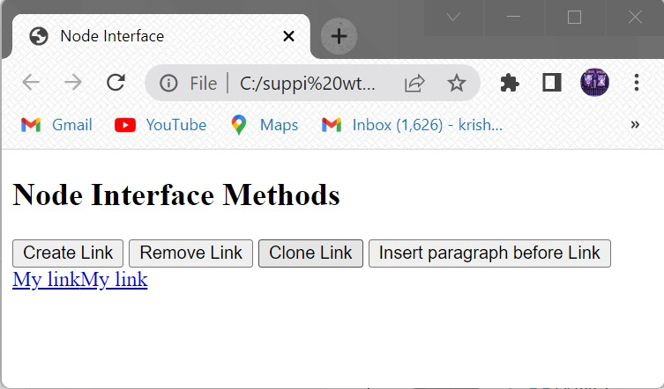

**Removelink:**

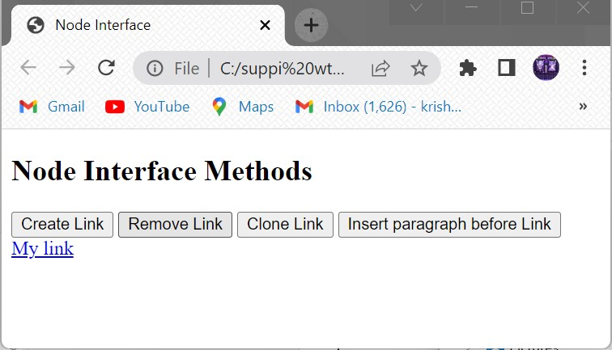

**Insert paragraph before link:**

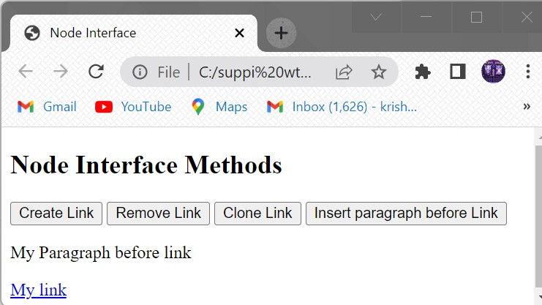

**AIM:**

**SOURCECODE:**

<!DOCTYPE HTML>

<html>

<head>

<script type="text/javascript">

function dis(val)

{

document.getElementById("result").value+=val

}

function solve()

{

var x = document.getElementById("result").value

var y = eval(x)

document.getElementById("result").value = y

}

function clr()

{

document.getElementById("result").value = ""

}

</script>

</head>

<body>

<table >

<tr>

<td colspan="3"><input type="text" id="result" ></td>

<td><input type="button" value="c" onclick="clr()"/> </td>

</tr>

<tr>

<td><input type="button" value="1" onclick="dis('1')"/> </td>

<td><input type="button" value="2" onclick="dis('2')"/> </td>

<td><input type="button" value="3" onclick="dis('3')"/> </td>

<td><input type="button" value="/" onclick="dis('/')"/> </td>

</tr>

<tr>

<td><input type="button" value="4" onclick="dis('4')"/> </td>

<td><input type="button" value="5" onclick="dis('5')"/> </td>

<td><input type="button" value="6" onclick="dis('6')"/> </td>

<td><input type="button" value="-" onclick="dis('-')"/> </td>

</tr>

<tr>

<td><input type="button" value="7" onclick="dis('7')"/> </td>

<td><input type="button" value="8" onclick="dis('8')"/> </td>

<td><input type="button" value="9" onclick="dis('9')"/> </td>

<td><input type="button" value="+" onclick="dis('+')"/> </td>

</tr>

<tr>

<td><input type="button" value="." onclick="dis('.')"/> </td>

<td><input type="button" value="0" onclick="dis('0')"/> </td>

<td><input type="button" value="=" onclick="solve()"/> </td>

<td><input type="button" value="*" onclick="dis('*')"/> </td>

</tr>

</table>

</body>

</html>

**OUTPUT:**

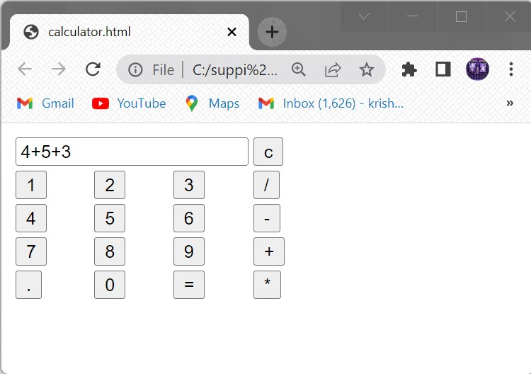

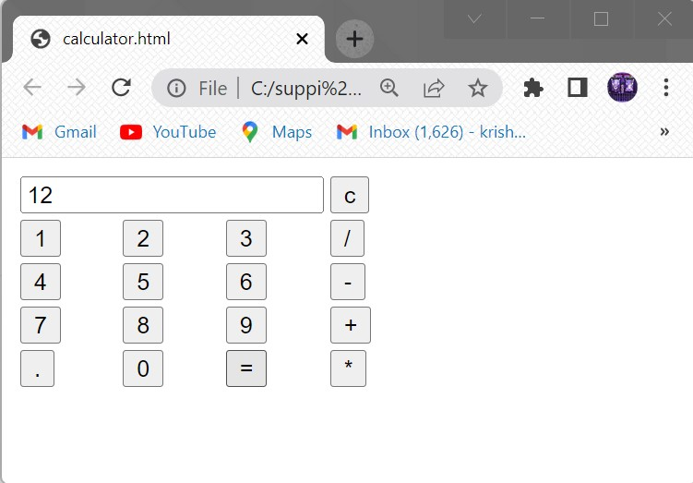

**AIM:**

**SOURCECODE:**

<?xml version='1.0' encoding="UTF-8"?>

<!DOCTYPE student[

<!ELEMENT student (name,regd,address)>

<!ELEMENT name (#PCDATA)>

<!ELEMENT regd EMPTY>

<!ATTLIST regd id CDATA "401">

<!ELEMENT address (dno,city,street)>

<!ELEMENT dno (#PCDATA)>

<!ELEMENT city (#PCDATA)>

<!ELEMENT street (#PCDATA)>]>

<student>

<name>apple</name>

<regd id="401"/>

<address>

<dno>1-36</dno>

<city>ramachandrapuram</city>

<street>nehru nagar</street>

</address>

</student>

**OUTPUT:**

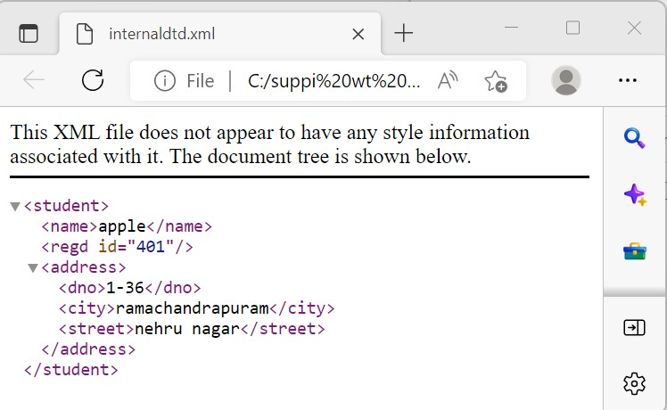

**AIM:**

**SOURCECODE:**

**External.xml:**

<?xml version="1.0" encoding="UTF-8"?>

<!DOCTYPE student SYSTEM "ext.dtd">

<student>

<name>apple</name>

<regd id="401"/>

<address>

<dno>5-12</dno>

<city>kanigiri</city>

<street>neelakantam vari street</street>

</address>

</student>

**Dtdfile:**

<!ELEMENT student (name,regd,address)>

<!ELEMENT name (#PCDATA)>

<!ELEMENT regd EMPTY>

<!ATTLIST regd id CDATA "401">

<!ELEMENT address (dno,city,street)>

<!ELEMENT dno (#PCDATA)>

<!ELEMENT city (#PCDATA)>

<!ELEMENT street (#PCDATA)>

**OUTPUT:**

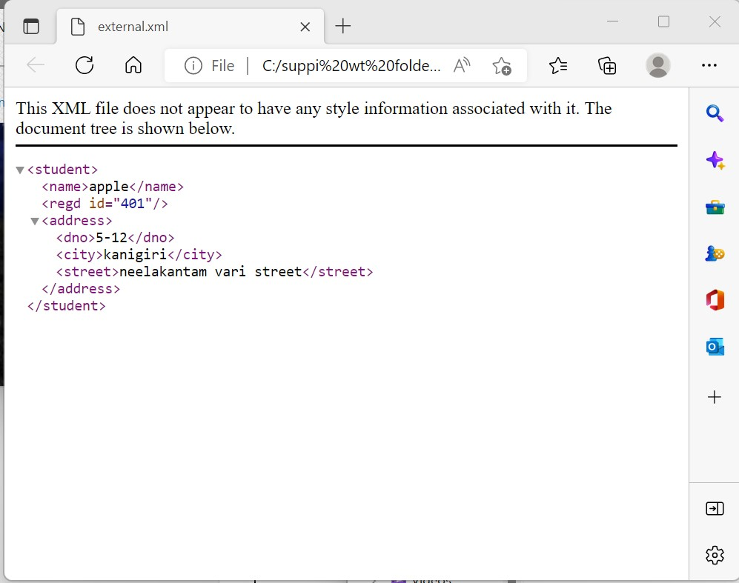

**AIM:**

**SOURCECODE:**

Xmlfile:

<?xml version="1.0"?>

<student branch="it">

<name>apple</name>

<regd>y20ait470</regd>

</student>

Xsdfile:

<?xml version="1.0"?>

<xs:schema xmlns:xs="http://www.w3.org/2001/XMLSchema">

<xs:element name="student">

<xs:complexType>

<xs:sequence>

<xs:element name="name" type="xs:string"/>

<xs:element name="regd" type="xs:string"/>

</xs:sequence>

<xs:attribute name="branch" type="xs:string"/>

</xs:complexType>

</xs:element>

</xs:schema>

**OUTPUT:**

